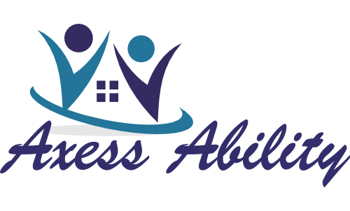
COMPLAINT HANDLING PROCEDURES

WHAT IS A COMPLAINT?
A “Complaint” is a claim by a person that Axess Ability has acted unreasonably towards any person receiving services.
If you think that something should have been done differently or that something has not been done, then you have a right to make a complaint and have it fixed.

WHAT SHOULD I DO IF I HAVE A COMPLAINT?
The person will raise the matter with a Partner/staff member to identify what the issue is and how they expect it can be resolved.
You need to tell the person providing care about what issue you have about the care provided. You should clearly state what the problem is and how you would like it to be resolved. It may be necessary for you to raise the issue with the Partner’s to give them an opportunity to resolve the issue.

WHAT IF THE COMPLAINT IS NOT RESOLVED?
When an issue cannot be resolved to the satisfaction of the person, the person in-charge will explain the complaint handling process used by Axess Ability. Where the person decides to make a formal complaint, the person in-charge will assist the person to complete a Complaint Form.
When you are not satisfied with the way the complaint has been handled, you should make a formal complaint. The Partner’s of Axess Ability will explain what to do and help you fill in the form [if you are unable to fill in the form the Partner’s will fill it in with you}.

WHAT THEN HAPPENS TO YOUR COMPLAINT?
When the Partner’s receive a complaint form, he or she will talk to the staff and find out what ways the complaint may be able to be resolved. In some cases the Partner’s may need to seek a Committee member or an independent person to investigate the matter and provide a report on the issue. If an investigation is needed to examine the matter, the person making the complaint will be informed of progress during the investigation.
You will be told what is happening to the complaint as soon as possible. The Partner’s will gather all relevant information and may be able to give you a satisfactory resolution to the matter. If the issue is more complex, then you will be told in writing within 5 days of the complaint, what action is being taken by Axess Ability. When an investigation of the issue is needed, you will be regularly informed of what is happening.

WHAT IF MY COMPLAINT IS NOT RESOLVED?
When the complaint has been investigated the Partner’s will contact the person making the complaint and explain how Axess Ability plans to resolve the matter. The person making the complaint may accept the proposed resolution and the issue is then considered resolved. However the person may wish to appeal this decision and ask the Committee to consider their appeal. If the appeal is unsuccessful, the President of the Committee will explain other external bodies that can be asked to assist with the complaint.

